My Personal & Reader Profile

Figure 1.1. What is your Reader Profile?

My Identity is… | So I read…
A Political Junkie  TV and Movie Buff  ESL Teacher  Soccer fan  French Speaker | Newspapers, online news sites and blogs  Online movie sites, critics, movie news  Grammar Books, linguistic articles  Belgian & French Sports news online  Belgian & French Newspapers online

Figure 1.2. Revisiting your Reader Profile: Choice Texts Versus Obligation Texts

Choice Texts  I wanted to read… | Obligation Texts – Personal  (I felt obligated to read…) | Obligation Texts – Others  (Someone else obligated me to read…)
Political Books  Daily Online News Articles  Daily Online Movie Articles  Ex: Time Magazine, NY Times, Washington Post, Courier International…  E-mails from Friends/Family | AOAO Documents  Online Macbook instructions  Bank Documents  Real Estate Documents  KCC & UH Registrations & Refund Rules  Airline Reservation Rules  Employee Rulebook | Anything class related such as articles  Science related notes in Middle & H.S. in Belgium and at KCC in Hawaii

Figure 1.7 What is your profile as a Disciplinary Reader?

 | Literary  Fiction | Mathematics | Physical  Science | Biological  Science | History | Social  Studies | Technical | Health &  Fitness | Humanities
Highly
Confident
Generally  Competent | X |  |  |  | X | X |  |  | X
Can Get By |  |  |  |  |  |  |  | X
Sometimes
Struggles
Often  Struggles |  | X |  |  |  |  | X
Avoids at  All Costs |  |  | X | X

Timeline

1973 (Birth) 1992 (High School Graduation) 1992 (Hotel Opening)

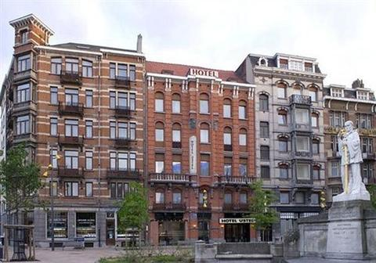

1997 2007 (Enrolled at KCC) 2009 - 2013 (Freeman Scholarship)
(graduation Hotel Management School)

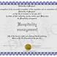

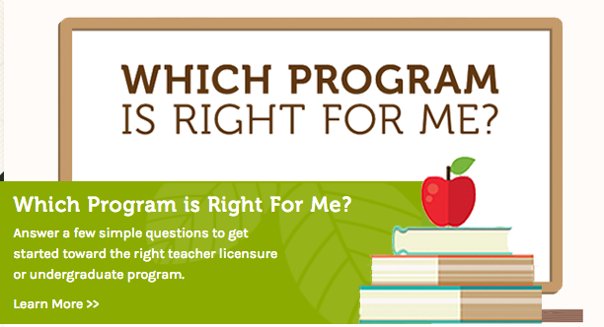
2014 (EF: Education First) 2017 (College of Education)

Timeline Detailed

1973 – Birth: As I reflect on my literacy identity journey, it started with the place of my birth, and my family background context. Both Buehl and Goodman discuss the importance of lifelines, communities and families in the creation of a literacy identity. I have always felt that my love of language came from being born in Brussels (capital of Europe and home to many languages) in Belgium (Two National Languages), from an American mother and Turkish father who communicated in French. Goodman in talking about parents, writes that “ they can involve their children in the cultural literacy events of their homes and communities” (p. 57) which is one way to develop their literacy. Mine was developed early on as I was spoken to in English, French, and some Turkish throughout my childhood. Those conversations were my cultural literacy events.

1992 – High-School Graduation: My Middle and High School years (1985 – 1992) had been, at times, difficult for me. As Buehl quotes Gee (2000), I was a “certain kind of person” (p. 3). I was part Turkish, part American, had a funny name, spoke different languages but at heart I was Belgian and shared that identity with the other kids. That was my “membership” or “association” that Buehl discusses as being an aspect of our identity. Throughout High School, I had been building my Belgian identity but as Johnston (2004) cited by Buehl, explained: “Building an identity means coming to see in ourselves the characteristics of particular categories (and roles) of people” (p. 8). When I graduated High School, after being forced/obligated to read/study topics I hated (science), I finally felt closer to my American and Turkish identity once again.

1992 – Hotel Opening: In 1992, my parents opened a 28-room hotel in Brussels, Belgium. That new event would become a part of my life for the next 13 years. Languages, through clients from around the world, would be a part of my life again. I learned how to read and write new documents (reservations, bills, business letters, advertisements, employee hiring documents, etc). Many colleagues became my mentors. Just like Robert Hanson mentored Buehl, that colleague mentored me in the Hotel Sales Department, another taught me about the front desk duties. As Buehl explained, I observed, watched, discussed, practiced, and then got feedback. And finally, I learned to be on my own.

1997 – Graduation Hotel Management School: In between shifts at the hotel, I went to Hotel Management School to better improve my various skills (front desk, marketing, reading and writing business letters, creating budgets, marketing plans). I had to become a new kind of reader and writer. A professional manager identity was a new goal. I was “expected to gradually grow capacities” (p. 14) in various areas. But just like Buehl, this “disciplinary literacy phase would reveal an uneven, jagged profile” (p. 14). I was, as Buehl mentioned, “more confident in some disciplines and (…) less effective in others” (p. 14). I became better in sales and marketing, and not as effective in reading about food and beverage, or any food related documents and classes.

2007 – Enrolled at KCC: In 2007, two years after landing in Hawaii, I decided to start a new academic adventure. Yetta Goodman discusses the “multiple roads to literacy”, this is yet a new one on my way to becoming an ESL teacher. I had to learn to read and write in an American academic way. My own skills and strategies needed to be updated as I entered my B.A in S.L.S at UH. I need to learn, and adapt in order to improve my writing and simply pass the classes. As Buehl writes, “disciplinary literacy is not one thing but many” (p. 14). In this case, it was the “technological road to literacy” that Goodman discusses. I had to learn to use new programs on my computer, new websites, and new ways of presenting information by computer (and thus, power point).

2009 – 2013 – Freeman Scholarship & Vietnam: But in 2009, a BIG event would redirect me once again. I applied for and got (along with 6 other students, including Jackie) a scholarship to study Vietnamese and travel to Vietnam the following year (in 2010). I would go back to Vietnam in 2012 and 2013 to teach EFL (English as Foreign Language). It opened my eyes to the literacy of others, not just my own any longer. Those experiences were (and still are) part of what Goodman described as “careful documentation of literacy histories of people from a range of socioeconomic backgrounds” (p. 59). In addition, as she explains further, “each road becomes part of the literacy history of our highly literate society” (p. 60). I discovered children, adolescents, adults whose English literacy was a way forward to a chance at a better life. It informed my identity and responsibilities as a language teacher.

2014 – EF (Education First): In 2014, I landed my first (and so far only) job as an English language teacher in Hawaii. This opportunity taught me how to create different kinds of lesson plans, different teaching methods, and different approaches to classroom management. The role of teacher became important, and as Buehl explains, “ as teachers, we can play a significant role in these dynamics of identity formation” (p. 8). I tried to be an encouraging voice, one that pushed for “academic identities that empower learning to begin to emerge” (p. 8) as opposed to previous teachers who had not done the same for me (in High School, at College in Belgium).

2017 – COE (College of Education): I am trying a new road to a new literacy discipline. Throughout my B.A and my M.A, I had been reading “out of obligation” not “out of choice” most of the articles given by the professors. I learned to improve my reading and writing strategies. Just as Buehl discussed “Reading in Academic Disciplines”, I had more interest in some disciplines more than others. I have “leaned toward and away” (p. 10) from certain disciplines. In the COE, I hope to develop some skills as a high school teacher.

